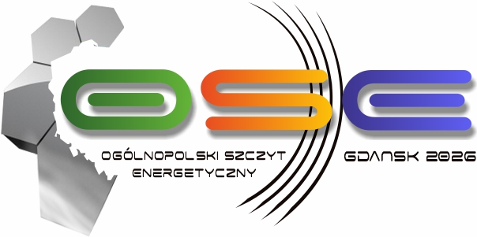

Ladies and Gentlemen,

European Business Centre in cooperation with the Gdańsk City and Pomeranian region authorities are honoured to invite you to participate in the 14th edition of the National Energy Summit OSE Gdańsk 2026, which will be held on 25th-26th May in Gdańsk. The leading theme of this edition is “Energy security of Europe - revision of European energy policy”.
The intention of OSE Gdańsk 2026 organizers is to gather the representatives of key institutions responsible for energy and economic security, politicians, economists and representatives of business and science in order to discuss the prospects for revision of European energy policy and its impact on the Polish economy and Polish Energy Policy 2050. Nuclear energy plans, focus on earth gas and biogas, renewables including offshore and innovation will again be addressed during specific panels on energy, gas, and heat are the key areas of the Summit. Additionally we dedicate one panel to the issue of cooperation among Baltic Sea states in the field of energy, gas, oil, renewables especially in the context of EU policy on strategic raw materials.
The revision of European energy policy will have a considerable impact on the Polish energy sector and the surrounding countries. This process - accompanied by the development of nuclear power plant and a number of smaller background changes affecting other industries and spheres of economy - will be addressed and discussed in specific panels. The detailed agenda will soon be available on www.osegdansk.pl.

We hope that the idea of this interesting and inspiring project will encourage you to join the speakers of OSE Gdańsk 2026. Looking forward to your reply, we remain.

Sincerely Yours,

Krzysztof Karaś
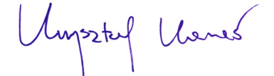
CEO ECB

