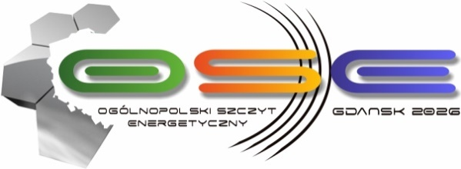

Event Name: 14th National Energy Summit OSE GDAŃSK 2026
Date: May 25-26, 2026
Location: Gdańsk, Museum of the Second World War
Theme: Europe's Energy Security – Revision of European Energy Policy
Organizer: European Business Centre

On May 25 and 26 of this year, we invite you to Gdańsk for the annual meeting of representatives from the worlds of politics, economy, science, and business during the OSE GDAŃSK 2026 Energy Summit.
The agenda includes topics related to investments in nuclear energy, the further development of offshore and biogas, the transformation of the heating sector, and critical infrastructure. OSE Gdańsk offers not only an opportunity to exchange experiences but also to learn about new trends in the energy, fuel, and gas industries, innovative technologies used in the sector, and solutions to ensure energy security.
Leaders from the worlds of politics, economy, and business invite you to a joint debate, main topics:
• Europe's energy security - a revision of European energy policy
• Adaptation strategies of energy groups in the energy sector transformation process
• Clean energy, investment scale, and key projects
• Security of strategic energy infrastructure
• Gas, biogas, and biomethane - a key element in building an efficient distributed energy sector
• New legal framework for the development of heating and cogeneration
• Off-shore & on-shore: development prospects, project scale, Polish component and installation manufacturers
• Horizon 2050: Development, investments, innovation - companies, local governments, prosumers

During the Summit, the "Amber of Polish Energy" statuettes will once again be presented, an award given to individuals, companies, institutions, or local governments for activities that have recently made a significant contribution to the development of the Polish energy sector, as well as the Amber Heart 2026 distinction. The Amber Heart is an award given to individuals, institutions, or companies for special activities in the field of philanthropy and CSR.
Join the group of participants and take part in an event that is a place for:
• building relationships,
• meeting leading experts,
• networking with representatives of the energy, gas, renewable energy, heating, and government sectors.

Detailed information and registration are available on the event website: https://osegdansk.pl/

